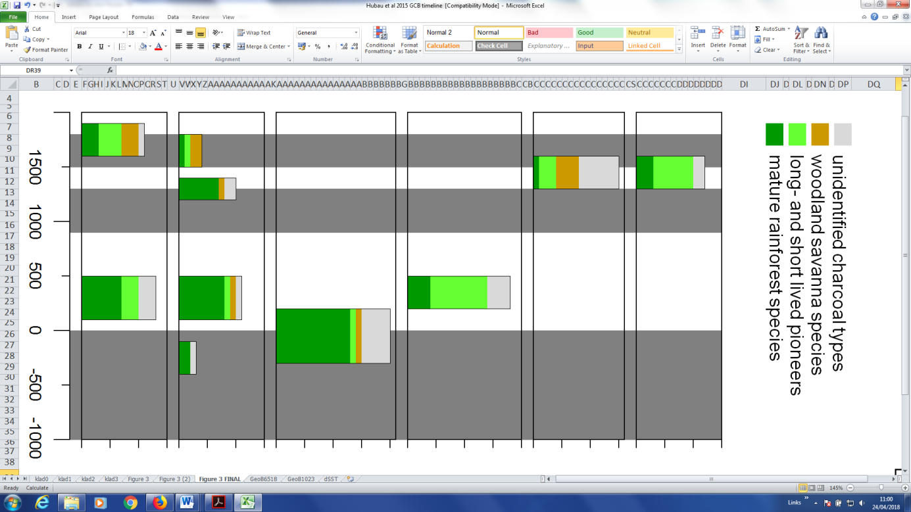

15

10

5

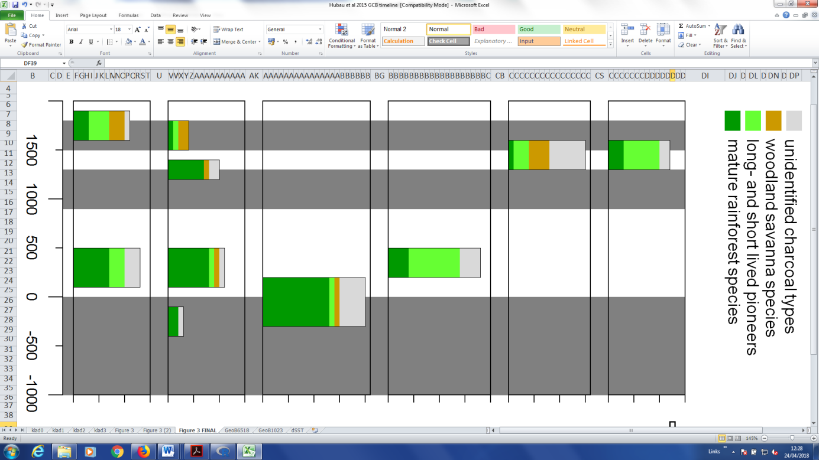

CZ3

15

10

5

CZ2

20

15

10

5

CZ1

Number of species per charcoal assemblage

20

15

10

5

UH48

15

10

5

KS8

15

10

5

0

KS9

Pit code :

-1000 -500 0 500 1000 1500

Age (cal BC/AD)

Fig. 2 Charcoal identification results from 6 pits excavated in the Mayumbe rainforest. Each box represents a pit, each colored histogram represents a charcoal assemblage formed during a fire event. The height of each histogram represents the number of taxa, colors refer to ecological preferences of the identified taxa (cfr legend). Identification of radiocarbon dated charcoal fragments showed that pioneer (light green) and woodland savanna taxa (brown) were sometimes still dominant in charcoal assemblages that were formed centuries after the actual disturbance periods (indicated as gray areas).This suggests that forest regeneration after the intense drought periods may have been a slow process, hampered by recurring fire events. Open savanna patches remained fire-prone even after the drought anomalies, and savanna fires may have impacted nearby forest edges and hampered forest encroachment. (Source: Hubau et al. 2015).